**Project: Woodson Park Academy & YMCA-ELC**

**Week Ending: June 14, 2019**

**THIS WEEK:**

* Demo Continues on existing school building.

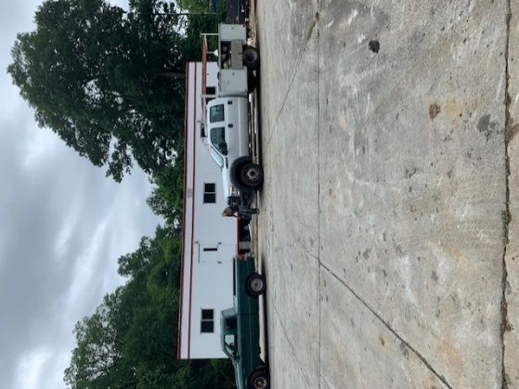 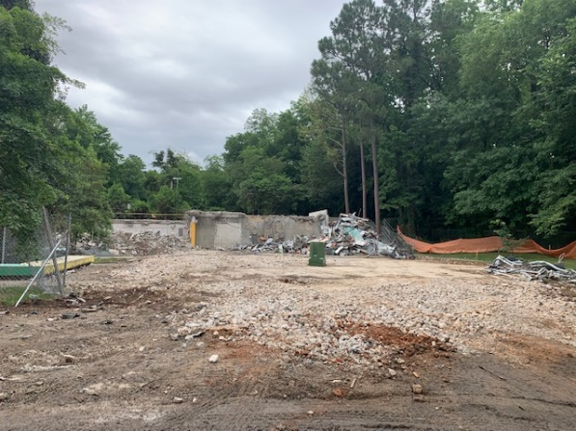

Office trailer set up ongoing Demo of entrance to old school building complete

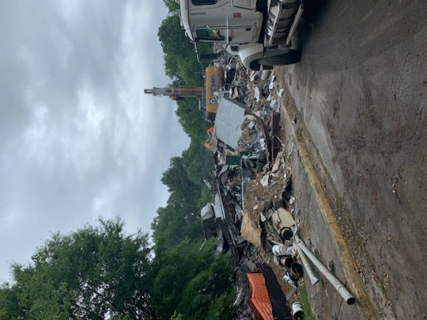 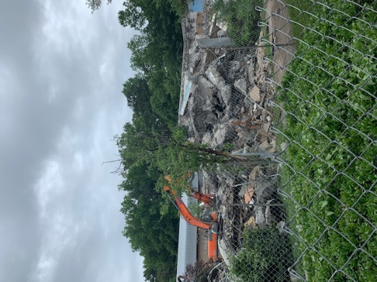

Demo continues on the existing All existing building but gymnasium demoed

School building

**NEXT WEEK – June 17 thru May 21:**

* Demo to continue
* Jobsite trailer utility hook up on going
* Install web cam

**SCHEDULED DATE OF SUBSTANTIAL COMPLETION**

* WPA – September 17, 2019
* YMCA-ELC - September 14, 2019

**PREPARED BY:**

* **Matt Dauber, Carroll Daniel Construction Co.**